** Example responses | Blue sections will be completed by CIPHA / Caldicot Guardian / Data Protection Officer

DATA ACCESS REQUEST FORM - Applicant Details
Project Name: | Tracking antimicrobial resistance across care settings in Liverpool Part 2 (TRACS-Liverpool part 2)
Date DARF is submitted:
Full Name:

Email Address:

Contact Phone Number:
Job Role:

Organisation:

Project intended Start Date:
Project intended End Date:

Project Details – Reason for Data Access Request

Project Name:

Project Description:

Project Values/Uses:

Transparency - provide a brief statement for the general public of the potential benefits that you expect the project to deliver: |  | Please avoid declarative language unless it can be justified i.e. “aims to” not “will”
Is there a commercial element to this project? (if yes, please provide details):

Project Output:

How do you plan to share data, results, and outputs from the work:

Intended Audience: e.g. DoH; Health and Care Providers; Patients, Public; etc.:

What Patient and Public Involvement and Engagement (PPIE) is planned or have been carried out in the system for this project?
Project Governance - where is the project reporting into routinely on delivery:

Legal Basis to Process Data: what you must meet:

Data Type | Common Law Duty of Confidentiality | UK GDPR  Article 6 & Article 9
Identifiable

Pseudonymised

Aggregate

How is the Common Law Duty of Confidentiality satisfied? |  | This doesn’t apply to pseudonymised or aggregate data. However, if there is use of identifiable data you must explain on what basis this will be met, e.g.  - Explicit consent  - Direct care met by implied consent  - Section 251 (state reference number)  - COPI Notice (state which one)
Lawful Basis for data processing under UK GDPR -  Article 6 and Article 9 Conditions: |  | This doesn’t apply to aggregate data.  Please refer to the legislation.gov.uk  Article 6 - Lawfulness of processing  Article 9 - Processing of special categories of personal data
Is this project covered by any other lawful basis: |  | For example - Section 251 (NHS Act 2006)
Data Controller(s) for this project - |  | List the organisation(s) that make decisions regarding how this data is going to be used:
Data Processor(s) for this project - |  | List the organisation(s) and named person(s) that will be processing this data:
For UK GDPR compliance, will the Data Controller(s) Privacy Notice(s) require an update:

Local Caldicott Guardian – checked & agreed  N.B. this must be completed before you submit your request |  | As the local Caldicott Guardian for this project I confirm that I am satisfied with this application.  Name:  Signature:  Position:  Date:  Add any other comments here:
Further Project Details

Is this project linked to a wider initiative, and if so, please provide details:

Is this part of an approved funded piece of work and if so by whom:

Are there any other organisations involved in this initiative? (if yes, please list them):

Details of any Data Protection Impact Assessments (DPIA) in place for this project: |  | - Population Health DPIA  - Unified Direct Care DPIA  - Population Health Action (CIPHA) Trusted Research Environment (TRE) DPIA  - Project has a local DPIA
Details of any Data Sharing Agreements in place for this project that cover this data flow and who they are between: |  | - Population Health (Tier Two) DSA  - Unified Direct Care (Tier Two) DSA  - Population Health Action (CIPHA) Trusted Research Environment (TRE) DSA  - Project has a local DSA
Details of any Honorary Contract arrangements for data access in place:

Data Access

Please indicate if the access is for identifiable / pseudonymised / aggregated data: | ☐ Identifiable |  | ☐ Pseudonymised | ☐ Aggregated
Which Programme is the data held under: | ☐ CIPHA |  | ☐ Share2Care | ☐ Empower
Please indicate if the access is for read only or a download to further process data in other ways:

Explain how you will ensure Data Minimisation, to ensure that you are only requesting and using the minimum data necessary for the project: | Explain how:  - You will only collect data you need for the specified purpose  - You have sufficient personal data to properly fulfil those purposes  - You periodically review the data held and delete anything not needed

Dataset(s) Requested | Description
What CIPHA data sets are being requested? | ☐ CIPHA GP Data  ☐ CIPHA Secondary Care data (Acute)  ☐ CIPHA Community data  ☐ CIPHA Social Care data  ☐ CIPHA Mental Health data  ☐ Vaccination data  ☐ Reference data: Please specify below
What NHS Digital datasets are being requested? | ☐ National Waiting List Data  ☐ SUS/ ECDS  ☐ CSDS  ☐ MHMDS  ☐ Adult Social Care  ☐ Mortalities
If there is an NHS Digital data access request, is this sharing covered by the NHS Digital DSA with the ICB
☐NA ☐Yes ☐No
If there is an NHS Digital data access request is an ICB sub-licensing Agreement required for NHS Digital Data Access?
☐Yes ☐No
What data environment is most appropriate?
☐DSCRO Azure DME ☐Graphnet
Describe the inclusion and exclusion criteria for the population cohort required for the project:

Data received from (organisation/organisations):

Data transferred to (organisation/organisations):

Data Flow Mapping: please describe the data flow between your organisation and others e.g. CIPHA to LA:

Method of secure data transfer:

How will patient objections be managed? Explain how you will meet type one objections or national data opt-out:  National opt out: prevents the sharing of identifiable data from NHSD for other reasons than individual direct care.  Type 1 opt out: if the patient does not want their person identifiable data to be shared outside of their GP practice for purposes except their own direct care.  Deleted as Graphnet diagram added | - National data Opt Out ** will not send any data to NHSD  - Type 1 – if an Opt Out code is present – ** will not store a record for any purpose other than direct care  - **National or Type 1 optouts are applied in the GP record so CIPHA will not collect that data.  - Patients will consent to participate and can request to withdraw at any time.

UK GDPR Special Category Data Item(s): | Justification: for UK GDPR purposes: give the reason why the data item(s) are needed:
Check all that apply:

☐ Data concerning health
☐ Racial or ethnic origin
☐ Political opinions
☐ Religious or philosophical beliefs
☐ Trade Union Membership
☐ Sex life and sexual orientation
☐ Genetic data
☐ Biometric data where processed to uniquely identify a person

Additional Information

Please add any additional information in support of your application request:

Your Signature & Date
Signature:

Date:

This Application will be considered at the Data Asset and Access Group (DAAG) and/or the C&M ICS Information Governance Strategy Committee

Please return to:
cipha@merseycare.nhs.uk

For help and support in completing this request form, please contact:
Suzanne Crutchley LLM
Head of Data Protection & Information Governance / ICS IG Lead
Suzanne.Crutchley@miaa.nhs.uk
Tel: 07717 720255

Graphnet Opt-outs - Implementation of GDPR, Type-1 and National data opt outs
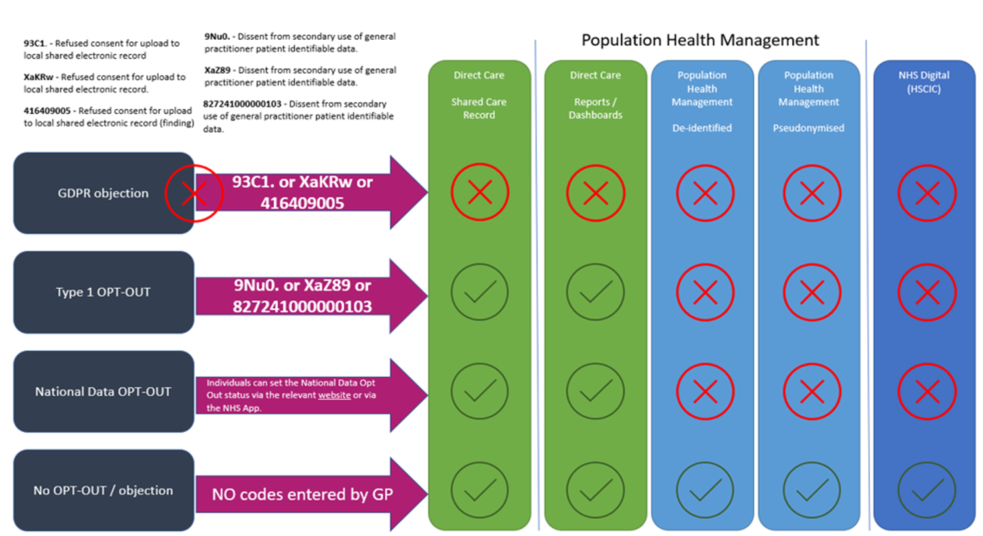

For DAAG/IGSC completion only:
Triage & Decision

Screening | Dates | Comments
Date received Access Request:

ICS Caldicott Guardian Triage check: |  | Checked by:  Comments:
ICS DPO Triage check:  ☐ Common Law Duty of Confidentiality satisfied  ☐ UK GDPR met  ☐ DPIA status  - linked to existing DPIA  - will require a DPIA  - DPIA not required  ☐ Data Sharing Agreement(s) status  - linked to existing DSA  - will require a DSA  - DSA not required |  | Checked by:  Comments:
ICS Technical Triage check:  ☐ Data compliant with DSCRO/ SUS/ no S.251 is necessary  ☐ Alignment to CIPHA/S2C/Empower priorities  ☐ Benefits articulated  ☐ Data flow mapped and understood |  | Checked by:  Comments:
Agenda item for DAAG/IGSC Meeting on:

DAAG/IGSC Meeting decision:

Any further requirements made:

Final outcome / decision

Version Control

Version | Stage | Date
0.1 draft | Initial submission
0.2 draft | CG Triage
0.3 draft | DPO Triage
0.4 draft | Technical Triage
0.5 draft | Decision
1.0 final | Final Decision

